MG2639: CONSUMER BEHAVIOUR
Resit Coursework 2025/26 - Individual Assignment
Bentley's Market Entry into India: A Consumer Behavior Analysis
Module Leader: Dr Dongmei Zha
Word Count: 1,957 (excluding coversheet, table of contents, executive summary, references and appendices)

Table of Contents
Executive Summary 3
1. Introduction 4
1.1 Overview of the Organization 4
1.2 Purpose of the Report 4
2. Consumer Behavior Analysis and Consumer Decision-Making Proposal 4
Part 1: Consumer Motivations and Psychological & Socio-Cultural Influences 4
Needs and Motivations 4
Psychological Factors 5
Socio-Cultural Factors 5
Part 2: Proposed Strategies on the Consumer Decision-Making Process 6
Problem Recognition 6
Information Search and Evaluation of Alternatives 7
Purchase Decision 7
3. Recommendations and Conclusion 8
References 9
Appendix 11
Appendix A: Bentley India Model Line-Up and Indicative Pricing 11
Appendix B: Key Market Statistics Referenced in this Report 12
Appendix C: Glossary of Key Terms 13

Executive Summary
This report assesses the psychological, sociological and environmental considerations that will influence consumer decision making as Bentley Motors, the British ultra-luxury carmaker owned by the Volkswagen Group, extends its reach into India through its newly established national entity Bentley India, a joint business formed by Skoda Auto Volkswagen India Private Limited in July 2025. The research, which is secondary data and drawn from published literature and newspapers reports of the automotive industry, indicates that India's huge population growth of very wealthy individuals is the main driver of luxuries in the automotive industry along with India's individualist-collectivist culture and its dependence on digital platforms for research and buying.
A three-stage consumer decision-making framework, covering problem recognition, information search and evaluation, and the purchase decision, is applied to propose practical strategies for Bentley India, including experiential brand activations, influencer-led digital storytelling and culturally resonant customization program. The report suggests that Bentley's sustainability remains key to its long-term competitive standing in India, and will rely heavily on global brand heritage and the perception of locally-oriented socio-cultural cues in the future, in particular using vehicles for the display of family status and solid sustainability credentials, along with other product configurations that suit Indian infrastructure like sport-utility vehicles.

1. Introduction

1.1 Overview of the Organization
British Motorsports manufacturer Bentley Motors Limited, manufacturing luxury motor cars over 100k BTs since 1919 now part of the Volkswagen Group. Along with the available Continental GT (INR 32 Lacs to 56 Lacs) and GT Convertible models, the Flying Spur saloon (INR 40 Lacs to 63 Lacs) and the Bentayga and Bentayga Extended Wheelbase SUV (INR 63 Lacs to 65 Lacs) are also part of the Indian line. (GoMechanic, 2025) The Bentley brand had been officially launched in India over 2 decades earlier with small independent importers, but limited to the pockets of the industrial families in 2 major Indian cities, Delhi and Mumbai (Bentley Media, 2025a). Changes for this English nameplate have been realized later in July 2025 when the Bentley brand's operation in India was handed over to Skoda Auto Volkswagen India Private Limited, a new direct sales model has been implemented in India with its local dealers' partnership in Mumbai, Bengaluru and Delhi. New showrooms of the flagships were opened in Mumbai and in Bengaluru (Bentley Media, 2025b) in October 2025. The decision to completely shift gears from deal to deal with an informal importer to an actual deal in India is Bentley's first tangible and business-minded initiative in India, which is expected to pick up pace with 100 units in the current fiscal year (autoX, 2025).
There are three major reasons why India is an interesting growth market. The ultra-high-net-worth individual count in India is projected to reach 19,908 by 2028, a 50% increase from the current figure of 13,263 (Dhuri, 2024). Second, the buyer profile is evolving to newer areas such as those of the younger technology entrepreneurs and executives, who make up nearly one-fifth of India's high-net-worth population, below age 45 years (MarkNtel Advisors, 2026a). Third, luxury vehicles account for approximately one per cent of the total car market in India, the lowest percentage among large economies, and the role & funding model for these cars is changing, leaving ample room for growth (Autocar India, 2026). Similarly, India's rich, tech-literate and self-assured shoppers are also important to Bentley's goals of expanding its reach to additional markets (Verified Market Research 2026).

1.2 Purpose of the Report
This report analyses the psychographic, sociological and environmental factors of the customer behavior, and comes up with some relevant recommendations on the brand being more successful in the field of market entry strategy in India. All analysis was based purely on secondary data from industry and market research reports, company press releases and peer-reviewed literature regarding luxury consumption and consumer behavior theory: no primary data was collected.

2. Consumer Behavior Analysis and Consumer Decision-Making Proposal

Part 1: Consumer Motivations and Psychological & Socio-Cultural Influences

Needs and Motivations
The ultra luxury does not end at the concept stage for India's UHNI and HNI buyers. An Ultra luxury deal is a much more conceptual affair for India UHNI/fire's wealth and power. Food processing service providers will embody Maslow's (1943) hierarchy of needs and fulfill so-called esteem and achievement needs by providing tangible signs of achievement after the needs concerning security and basic needs are met. In India the ownership of luxury cars is intricately related to the visibility of luxury items and the display of wealth, especially at times of marriage, and at a festival or at a family function, where a car denotes prestige and status in wider kinship groups (Bhar, Lele and Rao, 2022). Similarly, the industry reports that it is not only about moving house-holds are more and more interested in “experiences, exclusivity, and superior craftsmanship” (Verified Market Research, 2026). This is consistent with classic theories of consumer decision making of the problem recognition that results from a discrepancy between a desired state and an actual state (Engel, Blackwell and Miniard, 1995); in the case of Bentley's target segment, the desired state is clearly one of social rather than functional nature. This opportunity is comparable to that shown in Figure 1.
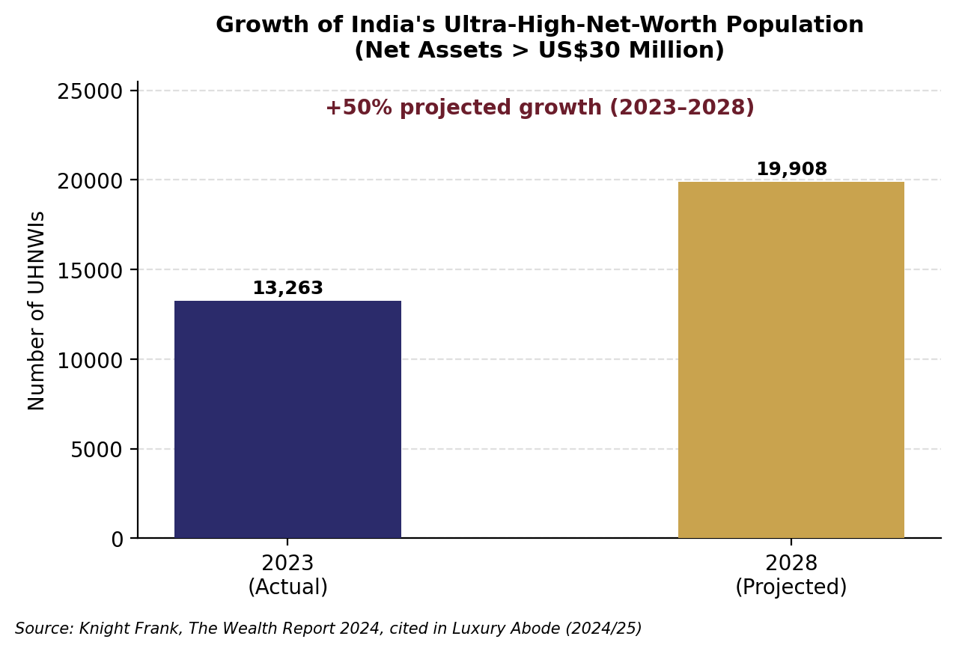
Figure 1: Growth of India's Ultra-High-Net-Worth Population
(Source: Dhuri, 2024)

Psychological Factors
Self-congruity theory holds that consumers favor brands whose image aligns with their actual or ideal self-concept (Sirgy, 1982), an effect especially pronounced in luxury, where brand identity extends personal identity and consumers gravitate toward brands that verify their desired social image (Xi et al., 2022). Under Bentley's British engineering and Mulliner's bespoke work, the focus is on the significant criteria 'achievement', which will appeal to the premium buyer who aspires to be more of a connoisseurship than a 'spender'. However, lifestyle segmentation too has a significant role as India's youth generation of luxury consumers, including entrepreneurs and young executives, are more experience-driven and tech-savvy than the setting of industrialists, and favor value innovation and personalization more than anything else when buying heritage (Indian Startup Times, 2026). This aligns with other lifestyle-segmentation practices in consumer behavior theory, in which lifestyle segments like activities-interest-opinions provide a more explanatory value than demographics in predicting purchases (Solomon, 2020), and suggests that the same line of storytelling for one buyer type won't be as effective in converting the other.

Socio-Cultural Factors
Hofstede's (2001) cultural dimensions provide an effective framework to understand India's socio-cultural context because India falls under the category of a society that is relatively high on power distance and has a combined individual-collective orientation. The voice of family and community is a potent influence, even among a successful wealthiest buyer, with acquisition decisions made based on how they will be viewed by a larger social circle (MarkNtel Advisors, 2026a). The increasing wealth of individuals, particularly young entrepreneurs, is concurrently promoting greater autonomy in decision making and creating two cultures of consumption. Sustainability is also becoming a brand value, with younger consumers associating eco credentials with technological sophistication than viewing them as incompatible with luxury so much so that Bentley's hybrid Bentayga and electrified roadmap hit the mark with consumers (CarWale, 2026).
A further environmental factor is India's road infrastructure. Heterogeneous road quality creates a structural utility premium for higher-ground-clearance vehicles; SUVs captured 47.43% of India's luxury car market in 2025, versus 52.57% for sedans, coupes and other body styles combined (The Report Cubes, 2026), shown in Figure 2.
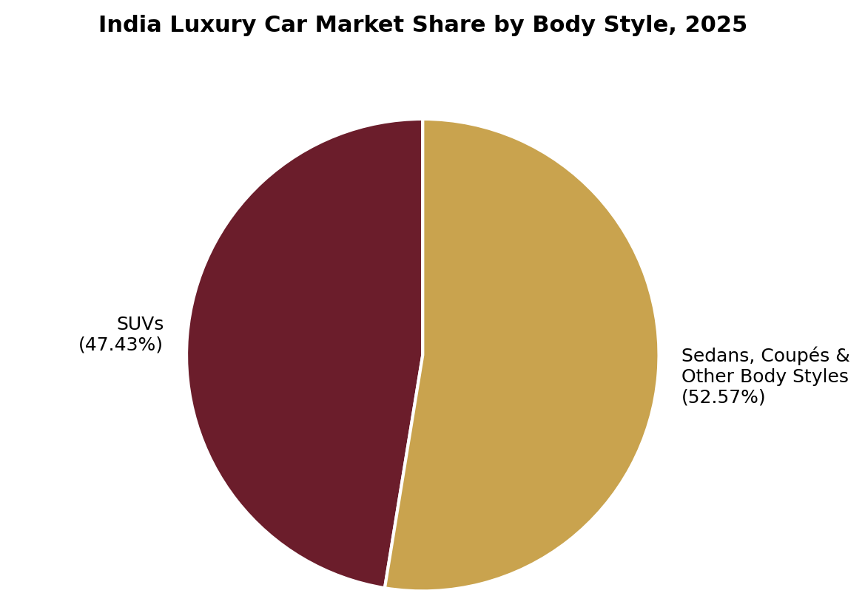
Figure 2: India Luxury Car Market Share by Body Style, 2025
(Source: The Report Cubes, 2026)
This is an advantage for Bentley's Bentayga over the Continental GT and Flying Spur outside the best-maintained metropolitan expressways. India's non-resident and mobile wealthy classes are already accustomed to holding Bentleys internationally, and most understand that the advantages of ownership travel with them much like service, rather than conform to local standards of displaying family values (MarkNtel Advisors, 2026a). Table 1 shows the major buyer archetypes that Bentley India will most likely face.
Table 1: Bentley India Buyer Archetypes
Segment | Core Motivation | Psychological Driver | Socio-Cultural Driver
Established industrialist families (Delhi NCR, Mumbai) | Legacy and status reinforcement | Self-actualization needs (Maslow, 1943), and esteem needs | Family and community display; high power distance
Young tech entrepreneurs & executives (<45, Bengaluru, Mumbai) | Personal achievement signaling | Self-congruity and achievement orientation (Sirgy, 1982) | Peer and online community validation
NRIs / Globally mobile buyers. | Global lifestyle continuity | Self-actualization, exclusivity | International identification; consistency of services;

Part 2: Proposed Strategies on the Consumer Decision-Making Process

Problem Recognition
Bentley India should design problem-recognition triggers around the emotional, status-driven needs identified above rather than functional advertising. Experiential activations, including invitation-only previews and motorsport-linked events, are consistent with observed patterns in India's ultra-luxury segment, where "concierge-led sales journeys, limited editions, and customization program are driving demand" (IMARC Group, 2026). BMW Group India's Retail. NEXT showroom in Delhi already blends immersive digital tools with concierge-style engagement (IMARC Group, 2026), setting a benchmark Bentley must match. Bentley's own showroom strategy, locating its Mumbai facility within The Galleria at the Trident Hotel and its Bengaluru facility within Indraprastha Invictus (Bentley Media, 2025b), is an appropriate sensory-trigger approach, positioning the brand within spaces its target consumers already associate with prestige. Live Mulliner customization demonstrations and curated launch events can make ownership aspiration tangible rather than abstract.

Information Search and Evaluation of Alternatives
The luxury automotive research journey has shifted to digital: Car shoppers spend over 90 per cent of their time on social media, and more than a third consult specific content produced by influencers during the decision-making process (Influencer Marketing Factory, 2025). What makes the name credible and why. Trusted sources should play a combination of influential brand voices who are credentialled in the industry and platform appropriate content: executives trust narratives on LinkedIn whereas a wider affluent audience responds to short-form video showing the emotional dimension of car ownership (AWISEE, 2025). Exclusivity, customization depth, after-sales quality and resale confidence, not just the price, matter to the luxury consumer in India focusing the post-purchase experience of reuse, repurpose, reportioned, recirculate, and recycle clearly resonating with the respondents as well (Agrawal et al., 2023). Therefore, the potential prospects of building a relationship between the journalists and the creator should be put at the top of the list for Bentley India, as trust-based content has proven less promotional and more valuable to users than short-term ad spend (Fullpath, 2024).

Purchase Decision
Brand reputation is still the focus, but it is increasingly balance by convenience such as financing, delivery periods, after sales depth etc., at the point of purchasing. The national sales company model is the initiative of Bentley India with the aim of achieving uniform national accessibility with the slogan "a buyer in Bengaluru can purchase any Bentley vehicle from Delhi or Mumbai, without any constraints" (Autocar India, 2026). This reduces friction often seen in importer-led retailing. It enhances the positive market growth rate witnessed in Figure 3 where brand India's luxury car market is predicted to grow from USD 4.2 billion in 2025 to USD 9.19 billion by 2032 (MarkNtel Advisors, 2026a).
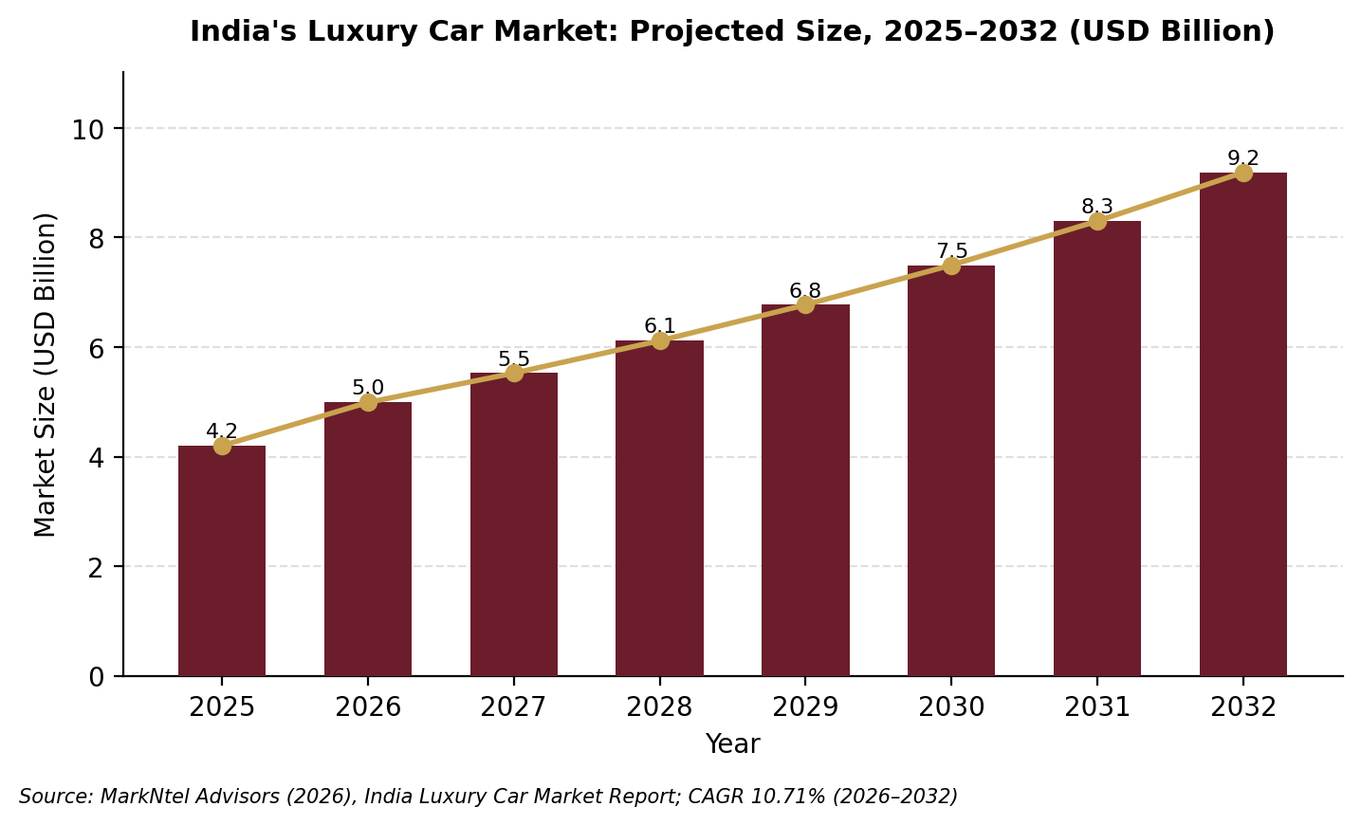
Figure 3: India's Luxury Car Market: Projected Size, 2025-2032
(Source: MarkNtel Advisors, 2026a; 2026b)
Peer influence is also important; the initial Bentley clients become unofficial brand ambassadors among the closely-knit UHNI customer base and thus referral companies are more powerful than discount-based sales to the masses which would cheapen the product. Pricing is already a key plank of the Bentley India case (Autocar India, 2026) and it could go hand-in-hand with more discreet financing options, in addition to a likely coming Free Trade Agreement between India and the UK that will bring duties down on completely built imports (CBUs) (Autocar India, 2026). Post purchase satisfaction in high involvement categories is heavily dependent on service experience meeting the pre purchase expectations: for Bentley, the ownership experience by its new national dealer network will need to always live up to the exclusivity they have created and marketed on the sales journey and for the Bentley brand, word of mouth will displace fair reviews on a small, very tightly connected social network.

3. Recommendations and Conclusion
The analysis of how Bentley has entered India's ultra-luxury car market documents a consumer segment driven by status and by the desire for self-actualization, influenced psychologically by the types of families using the car, and by the cultural mix of family driven status symbolism and individual digital discovery of the vehicle. Three recommendations follow.
First, Bentley India should develop segmented brand communications for its two principal buyer archetypes: heritage-led storytelling emphasizing craftsmanship and Mulliner customization for established industrialist families in Delhi NCR and Mumbai, whose decisions remain influenced by family perception (Bhar, Lele and Rao, 2022), and innovation-led storytelling emphasizing performance and electrification for younger entrepreneurs in Bengaluru, whose decision-making is more self-directed (Fullpath, 2024). Second, Bentley India should build a layered digital content strategy combining credentialed influencer partnerships with professional-network content for executives, supported by long-form, trust-building video rather than short promotional advertising (AWISEE, 2025). Third, Bentley India needs to continue working on its product mix based on the local infrastructure requirements, as the availability of the Bentayga and after-sales service are clearly beneficial in the SUV space, where road infrastructure varies drastically depending on the region (Mordor Intelligence, 2026).
The recommendations taken together indicate that ‘Global brand equity’ will not help make Bentley competitive in India. Long-term success requires aligning heritage with locally resonating status symbolism, promoting and offering new ways for wealthy digital-first customers to engage with the brand on channels they trust, and adjusting the retail experience, product flexibility and price discipline to the psychological and socio-cultural triggers uncovered in this report. The recommendations also have feasibility constraints: despite marketing, no volume will be achieved in the near term with the current three-city dealer network, and any FTA-imposed price reduction will require trade negotiations outside Bentley's hands which must be executed at some point beyond his current control. However, and this has been noted earlier, India's numerous ultra-high-net-worth individuals are expected to expand by 50% further by 2028, and even as a paltry per cent share of the entire vehicle sales market, growing succulent brand image is proving rewarding for those who see the sales mechanism as a social process.

References
Agrawal, C., Duggal, T., Shukla, V., & Dohroo, M. (2023). Analyzing the correlation between social media influencers and customers' intention to buy in the luxury market. Indian Journal of Marketing, 53(9), 28–45.
Autocar India. (2026). Bentley targets 100 cars per year milestone in India. https://www.autocarindia.com/car-news/bentley-targets-100-cars-per-year-milestone-in-india-439413
autoX. (2025). Bentley India is now official: First showrooms in Mumbai, Bengaluru, Delhi next. https://www.autox.com/news/industry-news/bentley-india-is-now-official-first-showrooms-in-mumbai-bengaluru-delhi-next-121167/
AWISEE. (2025). Influencer marketing for luxury cars: 6 best strategies in 2026. https://awisee.com/blog/influencer-marketing-for-luxury-cars/
Bentley Media. (2025a). Bentley Motors enters next phase in India with new national operations. https://www.bentleymedia.com/en/newsitem/1719-bentley-motors-enters-next-phase-in-india-with-new-national-operation
Bentley Media. (2025b). Bentley commences a new chapter in India with the opening of its new showrooms in Mumbai and Bengaluru. https://www.bentleymedia.com/en/newsitem/1744-bentley-commences-a-new-chapter-in-india-with-the-opening-of-its-new-showrooms-in-mumbai-and-bengaluru
Bhar, S., Lele, S., & Rao, N. D. (2022). Beyond income: Correlates of conspicuous and luxury consumption in India. Sustainability: Science, Practice and Policy, 18(1), 142–157.
CarWale. (2026). Bentley cars price in India – Bentley models 2026. https://www.carwale.com/bentley-cars/
Dhuri, P. (2024, December 29). India's luxury car market set to break records in 2025. Luxury Abode. https://www.luxuryabode.com/blog/indias-luxury-car-market-set-to-break-records-in-2025/artid3318
Engel, J. F., Blackwell, R. D., & Miniard, P. W. (1995). Consumer behavior (8th ed.). Dryden Press.
Fullpath. (2024). Automotive influencers: Why your dealership needs an influencer marketing strategy. https://www.fullpath.com/blog/dealership-influencer-marketing-guide/
GoMechanic. (2025). Bentley cars in India: Models, features & complete guide (2025). https://gomechanic.in/blog/bentley-cars-in-india/
Hofstede, G. (2001). Culture's consequences: Comparing values, behaviors, institutions and organizations across nations (2nd ed.). Sage Publications.
IMARC Group. (2026). India luxury car market size, share, growth insights, top brands & future opportunities 2026–2034. OpenPR. https://www.openpr.com/news/4421661/india-luxury-car-market-size-share-growth-insights-top-brands
Indian Startup Times. (2026). Top 15 marketing leaders driving India's luxury & premium automotive brands. https://www.indianstartuptimes.com/news/top-15-marketing-leaders-driving-indias-luxury-premium-automotive-brands/
Influencer Marketing Factory. (2025). Automotive influencer marketing: Best practices, case studies & strategies. https://theinfluencermarketingfactory.com/influencer-marketing-automotive/
Kotler, P., & Keller, K. L. (2021). Marketing management (16th ed.). Pearson.
MarkNtel Advisors. (2026a). India luxury car market is growing at 10.71% CAGR. https://www.marknteladvisors.com/research-library/india-luxury-car-market-report.html
MarkNtel Advisors. (2026b). India luxury car market to reach USD 9.19 billion by 2032, driven by rising premiumization and strong demand for luxury SUVs. Yahoo Finance. https://finance.yahoo.com/news/india-luxury-car-market-reach-092900762.html
Maslow, A. H. (1943). A theory of human motivation. Psychological Review, 50(4), 370–396.
Mordor Intelligence. (2026). India luxury car market analysis: Industry report, size & growth insights, 2031. https://www.mordorintelligence.com/industry-reports/india-luxury-car-market
Sirgy, M. J. (1982). Self-concept in consumer behavior: A critical review. Journal of Consumer Research, 9(3), 287–300.
Solomon, M. R. (2020). Consumer behavior: Buying, having, and being (13th ed.). Pearson.
The Report Cubes. (2026). India luxury car market size, share, trends and report 2026–34. https://www.thereportcubes.com/report-store/luxury-car-market-india
Verified Market Research. (2026). India luxury car market report: Size, growth, trends & forecast (2025–2033). https://www.verifiedmarketresearch.com/product/india-luxury-car-market/
Xi, X., Yang, J., Jiao, K., Wang, S., & Lu, T. (2022). We buy what we wanna be: Understanding the effect of brand identity driven by consumer perceived value in the luxury sector. Frontiers in Psychology, 13, Article 1002275.

Appendix

Appendix A: Bentley India Model Line-Up and Indicative Pricing
The table below summarizes Bentley's current India model range referenced in Section 1.1, provided here as supplementary detail rather than repeated in the main text.
Model | Body Style | Indicative Ex-Showroom Price (India) | Market Position
Continental GT / GT Convertible | Grand tourer coupe / convertible | approx. INR 3.45 - 3.83 crore | Performance / lifestyle
Flying Spur | Four-door luxury saloon | approx. INR 3.20 - 3.90 crore | Executive / chauffeur-driven
Bentayga | Sport-utility vehicle | approx. INR 3.83 crore (avg.) | Volume driver (SUV segment)
Bentayga Extended Wheelbase | Extended-length SUV | approx. INR 5.59 crore | Ultra-luxury SUV
Mulliner Bacalar | Bespoke limited-edition roadster | Price on application (12 units globally) | Ultra-exclusive / collector

Appendix B: Key Market Statistics Referenced in this Report
The table below consolidates the principal secondary-data figures cited throughout the analysis, for ease of reference.
Statistic | Value | Source
India UHNWI population, 2023 (net assets > US$30m) | 13,263 | Dhuri (2024)
India UHNWI population, 2028 (projected) | 19,908 (+50%) | Dhuri (2024)
India luxury car market size, 2025 | USD 4.2 billion | MarkNtel Advisors (2026a)
India luxury car market size, 2032 (projected) | USD 9.19 billion | MarkNtel Advisors (2026b)
Luxury cars as share of India's total auto market | approx. 1% | Dhuri (2024)
SUV share of India's luxury car market, 2025 | 47.43% | Mordor Intelligence, cited in The Report Cubes (2026)
Sedans/coupes/other body styles, 2025 | 52.57% | Mordor Intelligence, cited in The Report Cubes (2026)
Car buyers consulting social media pre-purchase | over 90% | Influencer Marketing Factory (2025)
Bentley India annual sales target, FY 2026-27 | 100 units | Autocar India (2026)

Appendix C: Glossary of Key Terms
Term | Definition
HNI | High-Net-Worth Individual; broadly, an individual with substantial investable assets.
UHNWI / UHNI | Ultra-High-Net-Worth Individual; an individual with net assets above US$30 million (Knight Frank definition used by Dhuri, 2024).
NSC model | National Sales Company model: a direct manufacturer-owned distribution structure, replacing independent importer arrangements.
Self-congruity | The degree of match between a consumer's self-concept and a brand's image (Sirgy, 1982).
Conspicuous consumption | The public display of wealth through visible goods as a signal of social status.

